Lab 3
SFC Soda Pop Machine
Seth Ricks
11/3/2026
ECEN 470

Objectives
Become more familiar with Studio 5000 communication with Allen-Bradley machinery. Learn Sequential Function Chart programing by creating a simulated pop machine with input switches and output LEDs and strings.

Task 1:
- Use Factory Talk to properly connect to the Allen-Bradley controller, using the IP-address inscribed on the casing.
- Create a new program and discover backplane modules.
Task 2:
- Create state machine concept drawing to understand the mechanism of the pop machine
Task 3:
- Create controller tags for input switches, output LEDs and strings
Task 4:
- Implement each soda pop machine state using a sequential function chart. These states are:
  - INIT
  - Selection
  - Music_on
  - Mixer_on
  - Drop_cup
  - Dispense
  - Add_ice
  - Finish $→$ Back to INIT
Task 5:
- Ensure functionality of machine and pass with instructor / TA
- Take video of to demonstrate machine functionality.
- Save project to GitHub for future reference, and to avoid wiping on school computer

Procedures

Equipment and supplies
- A school computer with Studio 5000 and FactoryTalk installed, and an Allen-Bradley CompactLogix controller.

Task 1:
The first thing that needed to be done was connect to the Allen-Bradley controller. This proved to be more complicated than expected. We had already written a little snippet of code in the SFC that was incomplete and had errors. The controller refused to connect until we had resolved those errors, even if we didn’t want to necessarily run the code yet. After connected, we also had to add and uninhibit the slots on the controller. This was done in the same manner as the previous labs.
To ensure that we had connected to the controller properly, we attached a value to a local tag. This can be seen in Figure 1 below. When we changed the value of ‘LED_1,’ the corresponding LED attached to the controller was illuminated. Likewise, when we flipped the switch corresponding to the signal ‘Switch_1’ the tag value changed.

Figure 1: Manual Tag Observations

Task 2:
Before moving forward with the rest of the lab, we decided to create a concept drawing of the state machine we would be creating in the sequential function chart. This can be seen in Figure 2 below. This drawing proved to be more useful than previously anticipated, for a few reasons. This drawing helped us to better understand the overall functionality of the machine before we even started. It was crucial for task 3, which is creating the controller tags. Doing this drawing helped us to know what tags we needed to create all in one place. Drawing the state machine beforehand also helped us to clear up some misconceptions we previously had. For example, we thought that switch 2 was supposed to reset the machine during any state, but we learned that it was only after the machine had finished and we wanted to reset.

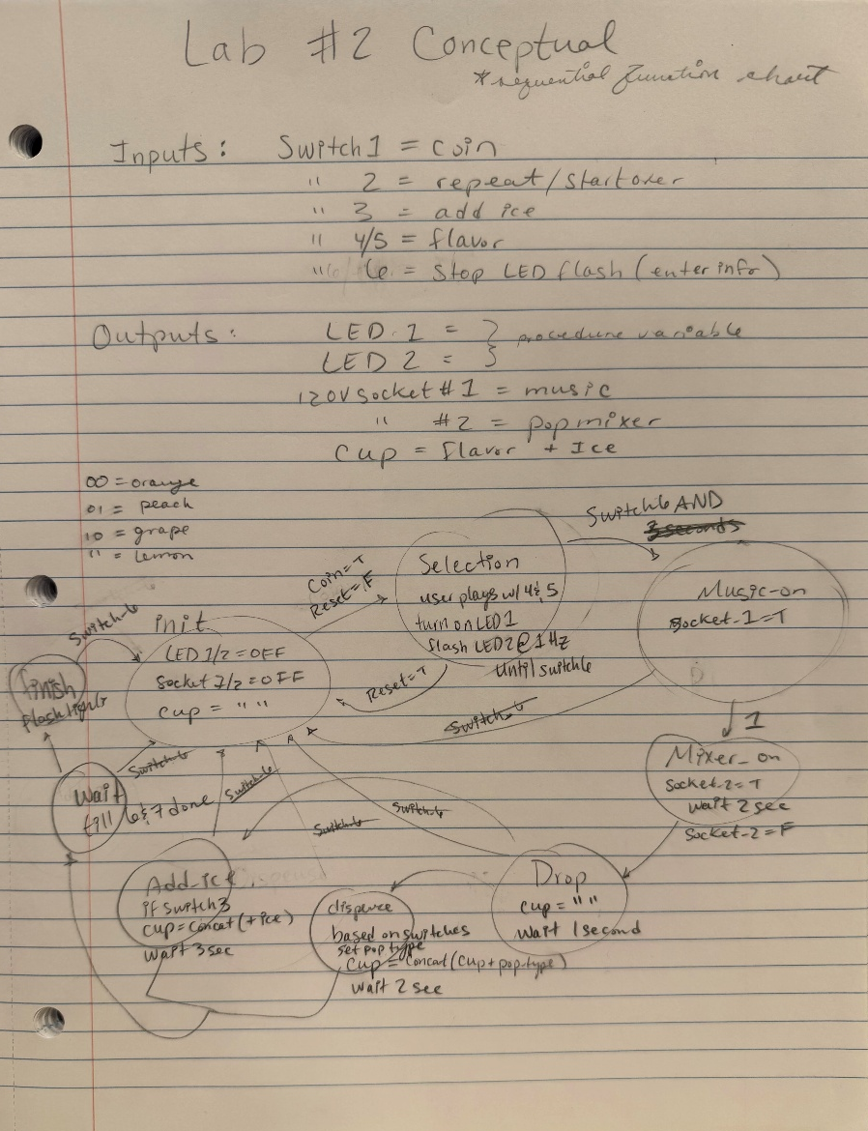
Figure 2: Concept State Machine Drawing

Task 3:
There were many controller tags that we had to create to successfully make this machine. They can be seen in Figure 3 below. They include hardcoded string values, local aliases for LEDs and switches, and labels for states, labels, and actions. Creating most of these tags beforehand helped speed up our process in creating the project, so we didn’t have to go back and forth creating them in the middle of writing the code.

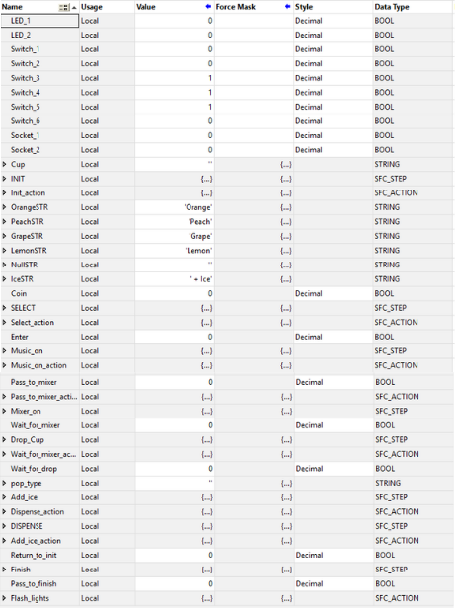
Figure 3: Controller Tags

Task 4:
After we created the appropriate controller tags, we were able to start writing the actual code. As previously indicated in both the task summary and the concept diagram, the states to implement were: INIT, Selection, Music_on, Mixer_on, Drop_cup, Dispense, Add_ice, Finish $→$ Back to INIT.
The first stages of our code can be seen in Figure 4 below. These include the INIT and Select stages. For the INIT (initialize) stage, we set all the output LEDs to 0, as well as setting the confirmation soda string to NULL. This restarts the program, so that it can be run again with a fresh state. Note that in the diagram below, the values for Socket_1 and Socket_2 are actually connected to LEDs 3 and 4. The transition after INIT, labeled ‘Coin,’ only allows the machine to leave the INIT state after Switch_1 has been toggled.
Next follows the Select state. In this stage, LED_1 is set high and LED_2 blinks at a frequency of 1 Hz. This is to indicate to the user that they are now able to select their choices for both pop flavor and ice. Once the user is done selecting their choices, they can toggle switch_6, which represents and enter key. This is indicated by the transition after the Select state, which only allows the state to continue once Switch_6 has been toggled.
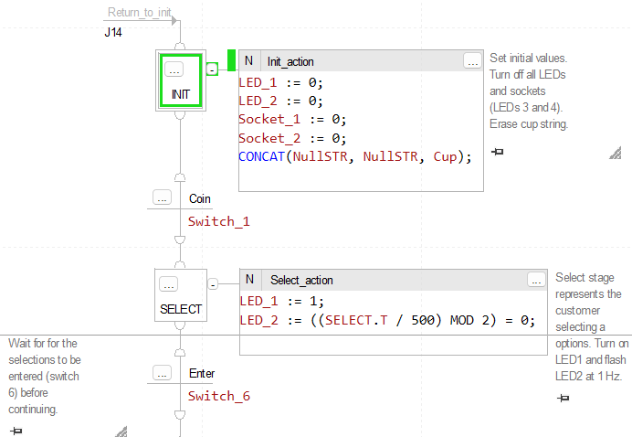
Figure 4: INIT and Select States

The states to follow are Music_on, Mixer_on, and Drop_Cup. These can be seen in Figure 5 below. In the Music_on state, Socket_1 (which is LED3) is illuminated. Immediately afterwards, the transition Pass_to_mixer passes the logic directly to the mixer_on state. This state turns on Socket_2 (which is LED4), representing the mixer being turned on. Note that these two states could be combined into one, but we were instructed to keep them separate.
After both the music and mixer have been turned on, the user must wait for two seconds before continuing. This is indicated by the wait_for_mixer state, which waits for the timer value on the mixer_on stage to be greater than 2000 milliseconds.
After the mixer has finished, the next state is Drop_Cup. This state turns off socket_2, indicating that the mixer has turned off. The Cup string is also set to null again to be safe, but is slightly redundant. The condition to leave the Drop_Cup state is continued in the next figure.

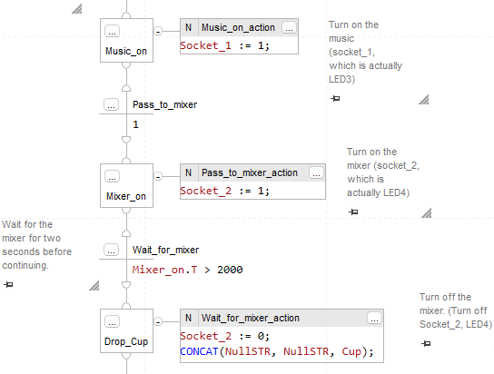
Figure 5: Music_on, Mixer_on, and Drop_Cup States

The condition to leave the drop state is to wait for the state to have been running for 1 second. This transition, called wait_for_drop, can be seen in Figure 6 below. After this transition, also seen in the figure, is the combined add_ice and dispense states. These run concurrently, and only once. This is indicated by the double bars and the P1 label on the action. The add ice action only concatenates a string with “+ ice” to the cup if switch 3 is activated. The dispense action always runs, as a soda flavor will always have been selected. A simple if statement controls how switches 4 and 5, which were the flavor selectors, translates in the appropriate string being populated into the cup variable. The condition for leaving the combined state is shown in the next figure.

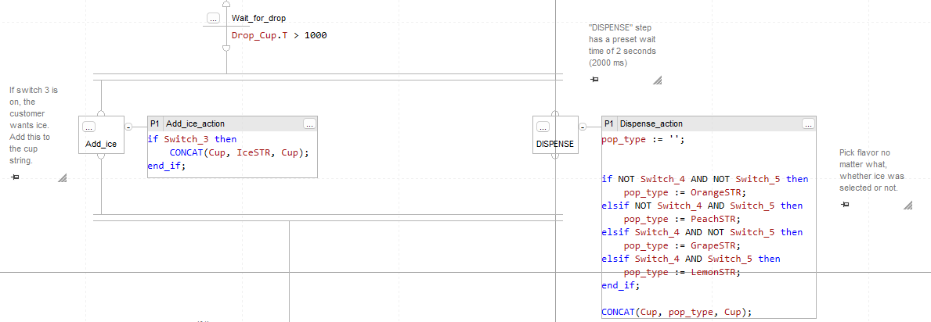
Figure 6:Add_Ice and DISPENSE States

The condition to leave the combined ice and dispense states state is slightly more complex than the other transitions. This transition, called Pass_to_finish, along with the Finish state and Return_to_init transition, can be seen in Figure 7 below. The Pass_to_finish state is two-fold. It needs to wait 2 seconds if no ice was being dispensed, and 3 seconds if ice was being dispensed. This represents how the machine would likely take longer time if certain options were selected. To do this, the transition uses some Boolean logic. If switch_3 is active, which represented the selection of ice, then wait on the add_ice timer for three seconds, if switch_3 is not active, wait for 2 seconds on the dispense timer.
The next state is Finish, which is definitely the most fun. This state celebrates sugar addiction by flashing LEDs 1-4 in a quick, cascading pattern. This is done with the modulus operator, dividing the timer in 4 for each LED. Once the user is sufficiently satisfied with the epic display of engineering, they can press switch_2 to continue the program back to the INIT state, and buy a soda all over again.

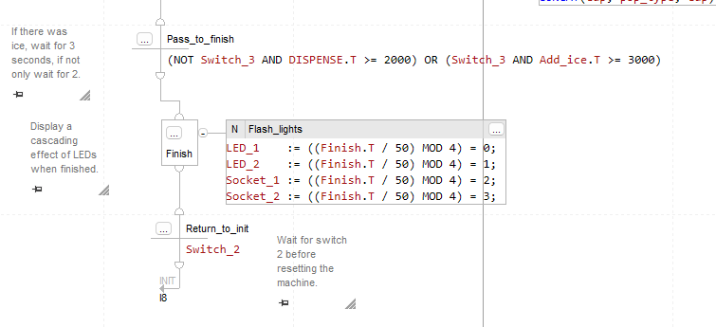
Figure 7: Finish State and Return_to_init Transition

Task 5:
To ensure proper functionality of the machine, this project was passed off with the instructor.
Follow this link to see a demonstration of the lab: Lab3 Demonstration Video
To ensure our code wasn’t wiped from the school computer, we saved a version of it on GitHub. Follow this link to see the code for this project: Lab3 GitHub

Conclusion:
The program worked as desired, but the purpose wasn’t to learn how to turn on LEDs. It was to learn how to take a complex idea, and turn it into something manageable.
The most important thing that I learned in this lab is that the different types of ways the state and transitions in sequential function charts can be combined to create different effects. For example, states can be set to run only once, or continuously for a prescribed amount of time. Transitions control when the states are to be finished running and can be a simple pass or a complex condition. The actions are what the states do while they are running, and can be simple or complex as well. The code inside of the action is similar to C, with a little bit different syntax. My personal analyzation of the difference between Steps and Transitions can be seen in Figure 8 below.

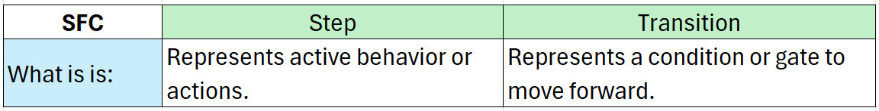
Figure 8: Step vs Transition in SFCs

